**Kindergarten Supply List**

**aug08_pencil1.gif2022-2023**

* 1 bath-sized towel labeled with name (to sleep on at rest time-this will stay in your child's cubby)
* 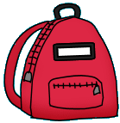1 backpack (without wheels and must hold a standard notebook)
* a complete change of clothes (including socks) in a Ziploc bag clearly labeled with your child's name
* 4 boxes of 24 count Crayola crayons
* 1 4 oz. bottle of Elmer's school glue

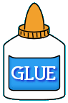

* 12 Elmer’s school glue sticks
* 1 box of Crayola broad line (thick) markers
* 1 box of Crayola fine tip (thin) markers
* 1 set of Expo dry erase markers
* aug08_marker3.gif1 pair of blunt tip Fiskar kids scissors
* 10-12 sharpened #2 yellow pencils
* 1 plastic pencil box

aug08_eraser1.gif

* 1 container Crayola watercolor paints
* Headphones (not earbuds)
* 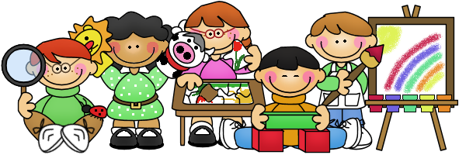1 four-count package of playdough